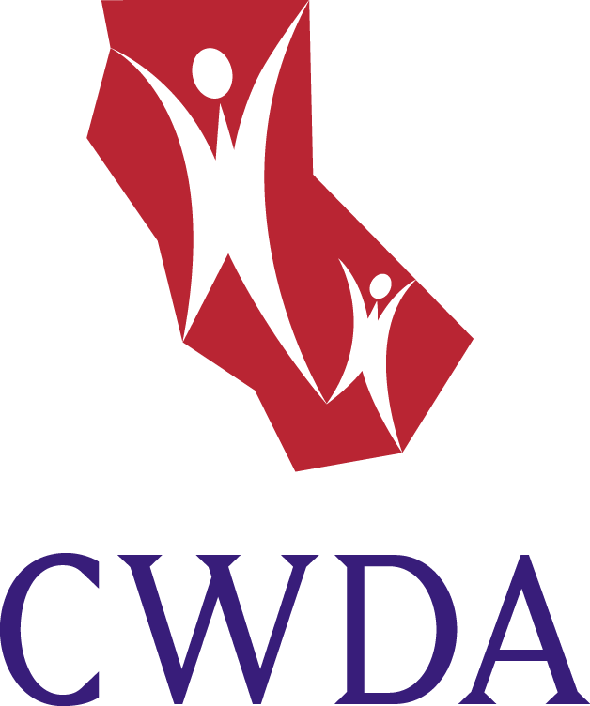

July, 2010

TO: All County Social Service Directors

FROM: Frank Mecca, Executive Director

RE: STATEWIDE CHILDREN’S SERVICES
INTERCOUNTY TRANSFER (ICT) PROTOCOL

To better serve children and families by facilitating the transfer of children’s services cases between counties, the Children’s Committee of CWDA updated a statewide Intercounty Transfer Protocol at its March 2010 meeting. The protocols update previous protocols in effect since March 2004 and the revisions have been approved by the 58 county welfare directors through signed acknowledgements which have been collected by the CWDA office. Counties should take the necessary steps to incorporate the provisions of this statewide protocol in local county ICT operations.

Please call if you have any questions, (916) 443-1749. Thank you.

