RFA SUPPORTS COMMITMENT
TO CHILDREN, YOUTH, YOUNG ADULTS AND FAMILIES
RFA reaffirms the commitment to serving children, youth, young adults and families because it:
Focuses on Lifelong Relationships
- RFA supports connecting children, youth, and young adults to safe, caring relationships that can last a lifetime by focusing on families.
- RFA's purpose is to place children, youth, and young adults with families than can provide a lifelong connection by determining permanency approval upfront.
Achieves Results for Children, Youth, Young Adults and Families
- Upfront training and ongoing services prepare caregivers to meet the needs of children and youth and assisting families with forming lifelong relationships.
- Supportive and loving long-term relationships lead to stable permanent placements and improved outcomes for children, youth, and young adults.
Improves Efficiency
- The new coordinated process will eliminate duplication, reduce paperwork, and maximize the efficient use of staff and system resources.

Consider Becoming a
Resource Family Today
ASK US HOW
For more information, contact:
Agency Name
[Street Address]
Phone: [Phone Number]
Fax: [Fax Number]
[www.]

[DEPARTMENT NAME]

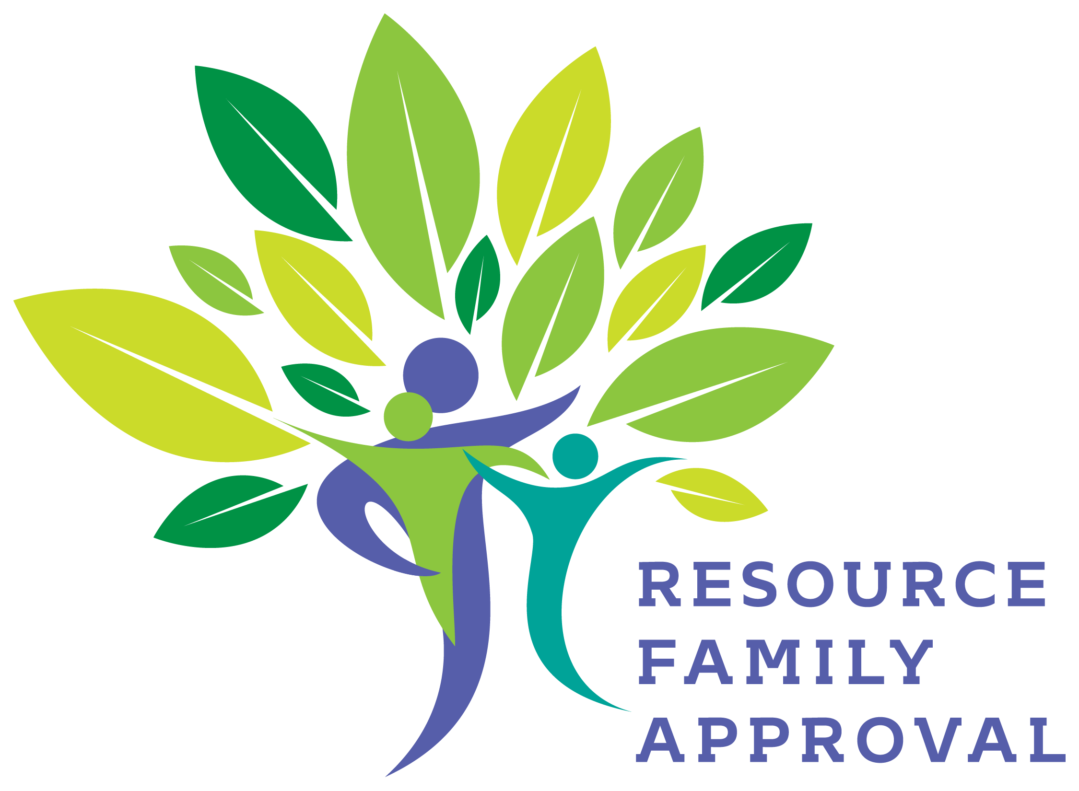
Becoming a Resource Family Through a Streamlined Foster Care and Adoption Process for Children, Youth, and Young Adults
Resource Family Approval (RFA)
All children need and deserve a safe, loving, nurturing, accepting, and consistent place to live where they can thrive and mature. Becoming a resource family caregiver provides
a home for a child to do just that.
Resource Family Approval (RFA) is a new caregiver approval process that a foster parent, relative, non-relative extended family member, or adoptive family completes to be considered for potential placement of a child, youth, or young adult (non-minor dependents from 18-21 years old).
RFA combines elements of the current licensing, relative approval, adoption, and guardianship processes.
RFA Streamlines the Approval Process
RFA is a unified, family-friendly and child-centered resource family approval streamlined process that includes one application, one background check, combined home environment and permanency assessments, pre-approval and post-approval training for all families.

RFA Requirements
There may be minimal costs associated with RFA. For more information, please contact
your county. The following is a partial list of requirements to be met prior to approval.
- Live Scan fingerprints
- Pre-approval and post-approval training
- Home environment assessment
- CPR/First Aid
- Health Screening
- DMV Report
The approval process also includes:
- In-home visits with all adults and
children, youth, and young adults
- Reference checks
- Collections of verifications and
completed application forms
RFA Facts
If a care provider is currently licensed, he/she will not be required to be assessed as an RFA care provider. If an existing foster family is ready to adopt, they may go through the adoption home study process or RFA process, depending on your county's policies and procedures.
Once approved, Resource Families may be considered for placement of related or unrelated child(ren) for foster care, adoption or legal guardianship, depending on the Resource Family’s goals. Resource Family Approval does not guarantee placement of a child. These decisions are determined by the child’s worker and the courts.
During an emergency situation, a child, youth
or young adult can be placed in a relative
home prior to approval if certain requirements are met.
- A home and grounds inspection
- Criminal record and Child Abuse Index check
- Initiation of RFA process within 5 business days if continued placement desired including
  - Completion or live scan background check within 10 days
  - Completion of RFA process within 90 days of placement

